War: what is it good for?
War makes a comeback in April with Frontline: Fields of Thunder and Silverfall.
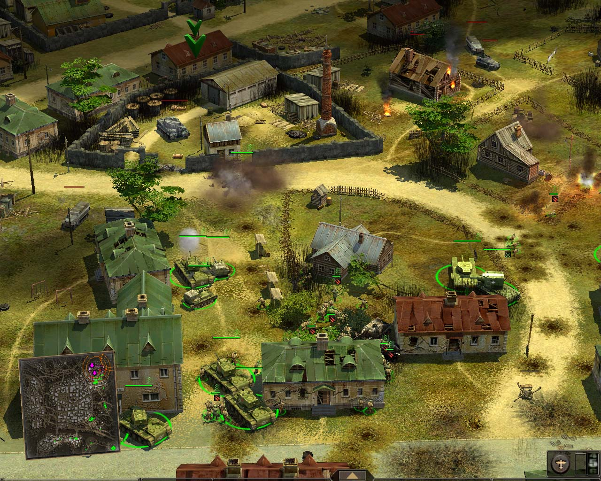
As the largest tank battle of all time, Kursk was the ultimate battle of the titans.
It was Germany’s last attempt to avoid defeat in World War II and was marked by a ferocity not previously seen by either side. Paradox recreates this horrific battle with great depth and detail. The game features 2 historically correct campaigns that encompass 20 thrilling missions, most of which are based on accurate historical episodes.
Creating much fanfare following its overseas launches, Fields of Thunder is being described as ‘more than an RTS’, with its strong sense of detail and intensity proving of great appeal to the war gaming crowd.

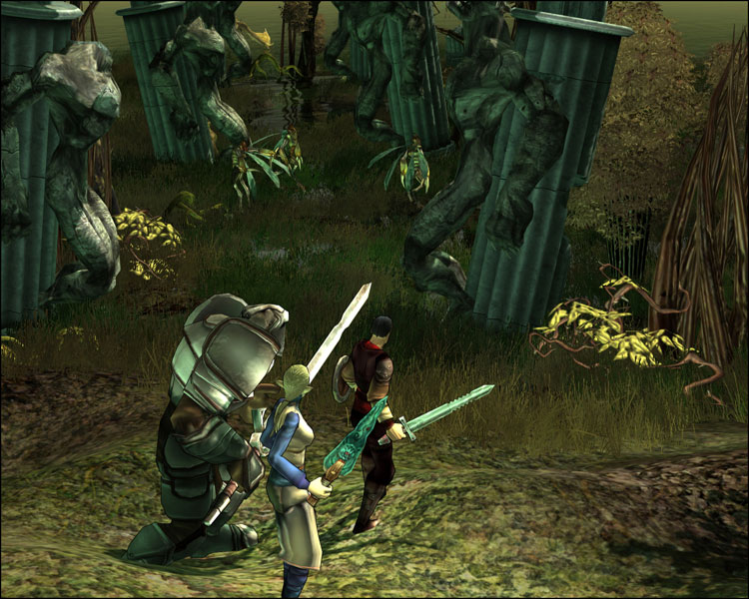
Silverfall brings conflict to the fantasy realm, pitting spell-casting nature lovers against hard bitten scientists in an intriguing battle to see who packs the biggest punch.
Based in the stunning kingdom of Nelwe, players are soon confronted with the chaos of this troubled society.
But whether you choose to evolve along a technological or spiritual path, you’ll need to choose your friends wisely as this is a dangerous world and your decisions will either save or destroy this once great kingdom.
Featuring a unique, pseudo cell-shaded art style, Silverfall is a treat to the eye whilst offering a unique spin on the standard good vs evil RPG formula.
The Australian launch of Silverfall is set for April 2nd.
Frontline Fields of Thunder launches on April 30th.

